**Program 1**

#include <iostream>

using namespace std;

int main()

{

int a,b,d,HCF,LCM;

// a and B are the input numbers

// d will be used to check remainders

HCF=0;

LCM=0;

d=1;

cout<<"Enter fisrt number."<<endl;

cin>>a;

cout<<"Enter another number."<<endl;

cin>>b;

for(d=1;d<=a||d<=b; d++)

{

if (a%d==0&&b%d==0)

{

HCF=d;

}

}

LCM=(a*b)/HCF; // This is the formula that gives the relation between LCM and HCF

cout<<"The LCM of the two numbers is "<<LCM<<endl;

}

**Output**

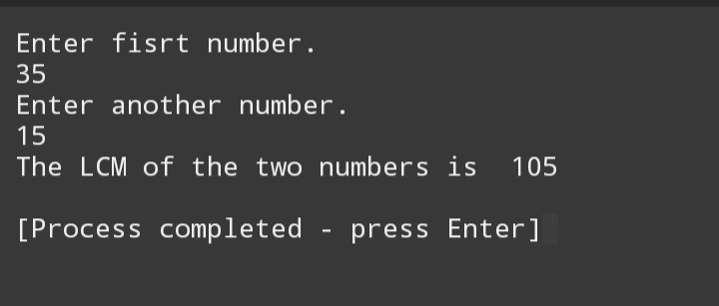

**Program 2**

#include <iostream>

using namespace std;

int main()

{

float a,n,d,sum;

// a is the first number of Arithmetic Series

// n is the number of terms

// d is the common difference between two adjacent numbers

cout<<"Enter the first number of Arithmetic Series"<<endl;

cin>>a;

cout<<"Enter the common difference of the Arithmetic Series."<<endl;

cin>>d;

cout<<"Enter the number of term (Nth term) up till you want the sum of the Series."<<endl;

cin>>n;

sum=(n/2)*(2*a+(n-1)*d);

cout<<"The sum of the Arithmetic Series up to the Nth term is "<<sum<<endl;

}

**Output**

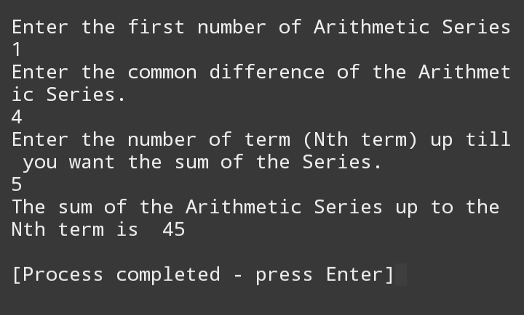

**Program 3**

#include <iostream>

using namespace std;

int main()

{

int n;

cout<<"Enter the number of rows for the diamond: "<<endl;

cin>>n;

for (int i = 1; i <= n; i++)

{

cout<<string(n - i, ' ')<<string(2 * i - 1, '*')<<endl;

}

for (int i = n - 1; i >= 1; i--) {

cout<<string(n - i, ' ')<<string(2 * i - 1, '*')<<endl;

}

return 0;

}

**Output**

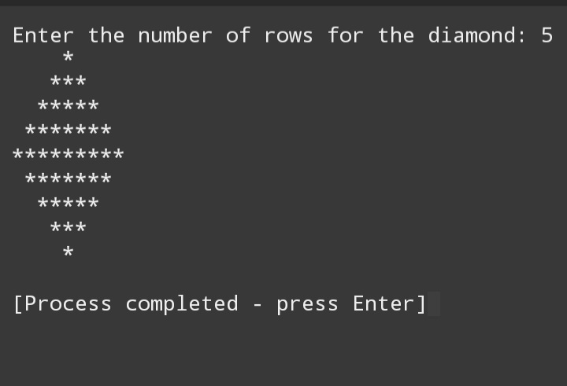

**Program 4**

#include<iostream>

using namespace std;

int main()

{

int num,count,bin[100];

cout<<"Enter a number"<<endl;

cin>>num;

for(int i=0; num>0; i++)

{

bin[i]=num%2;

num=num/2;

count++;

}

cout<<"\nBinary Equivalent is ";

for(int j=count-1; j>=0; j--)

{

cout<<bin[j];

}

}

**Output**

